Portfolio Development Document

Introduction

For this project I was tasked with creating a portfolio website to showcase my different skills, projects and give potential employers and insight into who I am as a potential future employee.

For my portfolio I tried to design a website that was fairly simple and self-explanatory for people to navigate around. I wanted the path through the website to be as simple and as obvious as possible, so I went for a linear design following an About me Technologies/Software Projects and Contact sections. Then from there the user could explore any projects I’ve worked on to give insight to my current skills and filter through the different technologies/software I have had prior experience in using.

Design Decisions

I wanted the overall design of my portfolio to reflect my love and passion for creativity, following a more traditionally inspired layout by using things like sticky notes, paper, polaroids, tape and other design choices to give a scrapbook feel to the website.

Overall, I went with a very pastel themed colour palette as a personal colour preference to my website. However, I did include a “Dark mode” as a lean to being more user and accessibility friendly, especially for people who may struggle to see such a light colour palette, but without having to compromising my own likes and design preferences in the process.

I also made sure to include aria labels and alt text, ensuring that people could comfortably tab through and use a screen reader to navigate through my website.

Testing Process

Along the way there were minor issues that myself and others I asked to test my web portfolio noticed, and that I made changes to improve accordingly. Some of the design and functionality changes that I made include:

Issue 1
Participant | Self-evaluation throughout development alongside feedback from family.
Task Set | Navigation through the portfolio and exploring the different project sections.
Issue Found | During the development I realised that in trying to turn my original prototype into a website it lacked the design necessary to feel like a website and less like a prototype. The nav bar was an example of a change I made to help overcome this issue.
Improvements Made | Redesigned the nav bar by adding rounded shapes, shadows and hover states.
Before:
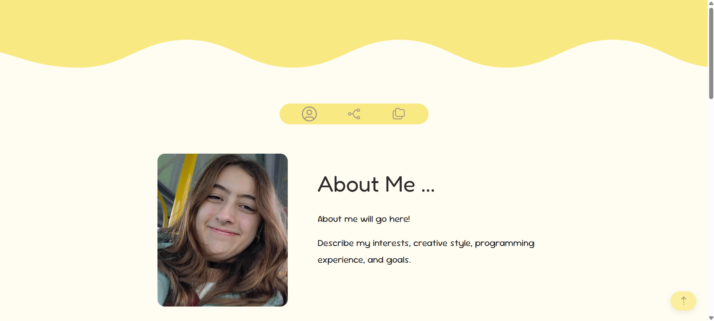

After:
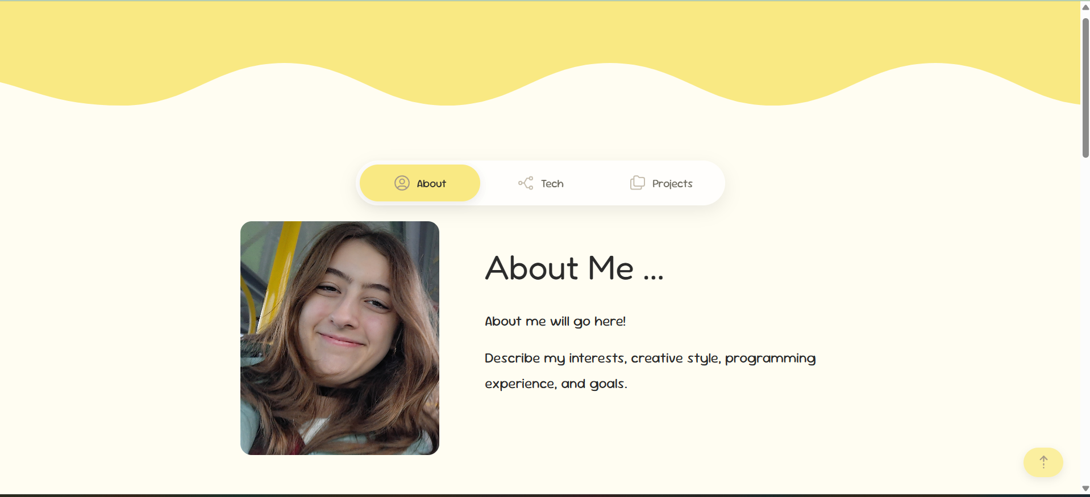

Issue 2
Participant | Classmates and friends.
Task Set | Navigation through the home page of the portfolio.
Issue Found | The users said it felt visually cluttered having the nav bar take us so much screen space whilst trying to view the different content on the website.
Improvements Made | Moved the nav bar higher so that visually it looked like it was part of the header, which created less clutter on the screen whilst keeping the quick and easy access that the nav bar provided intact across the website.

Before:
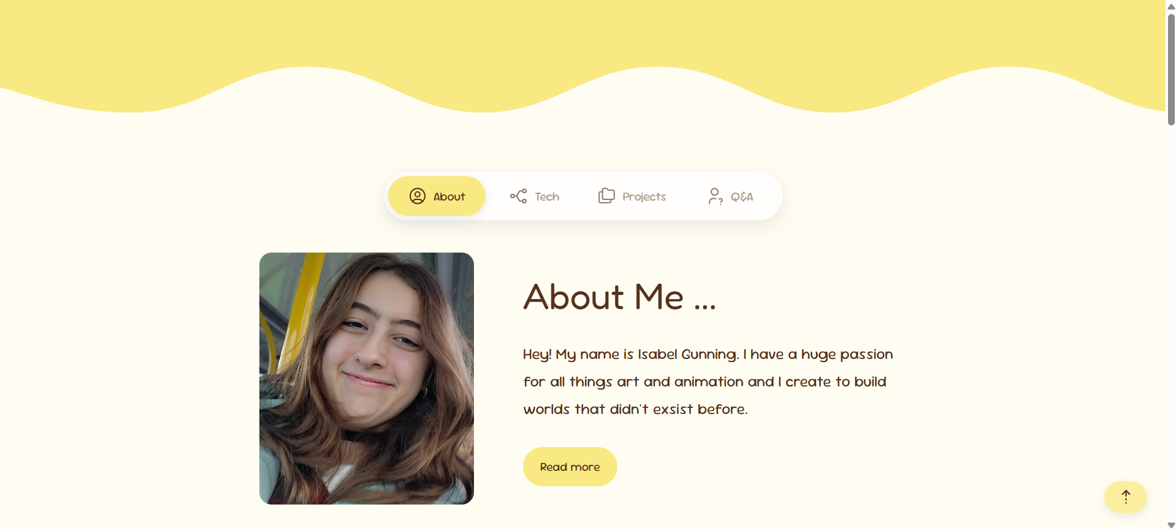

After:
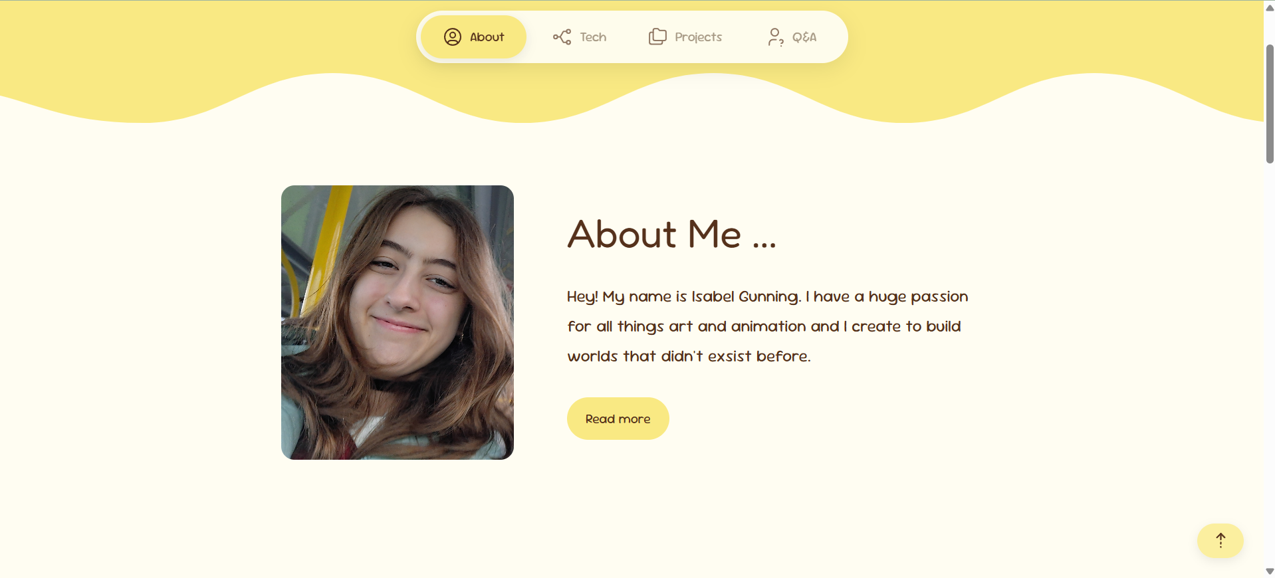

Issue 3
Participant | Self- evaluation.
Task Set | Project section layout and about me layout
Issue Found | Initially I designed the project section to just be folders that the user clicked to take them to their respective project pages. The about me section was also a similar issue in the sense that it felt very plain in comparison to the rest of the website.
Improvements Made | I decided it didn’t fit the traditional art design of the website and change it for polaroids to try and carry on the visual flow of the website. The about me section I added an animation to the text to display the different aspect of skills I will have after I finish my qualification
Before:

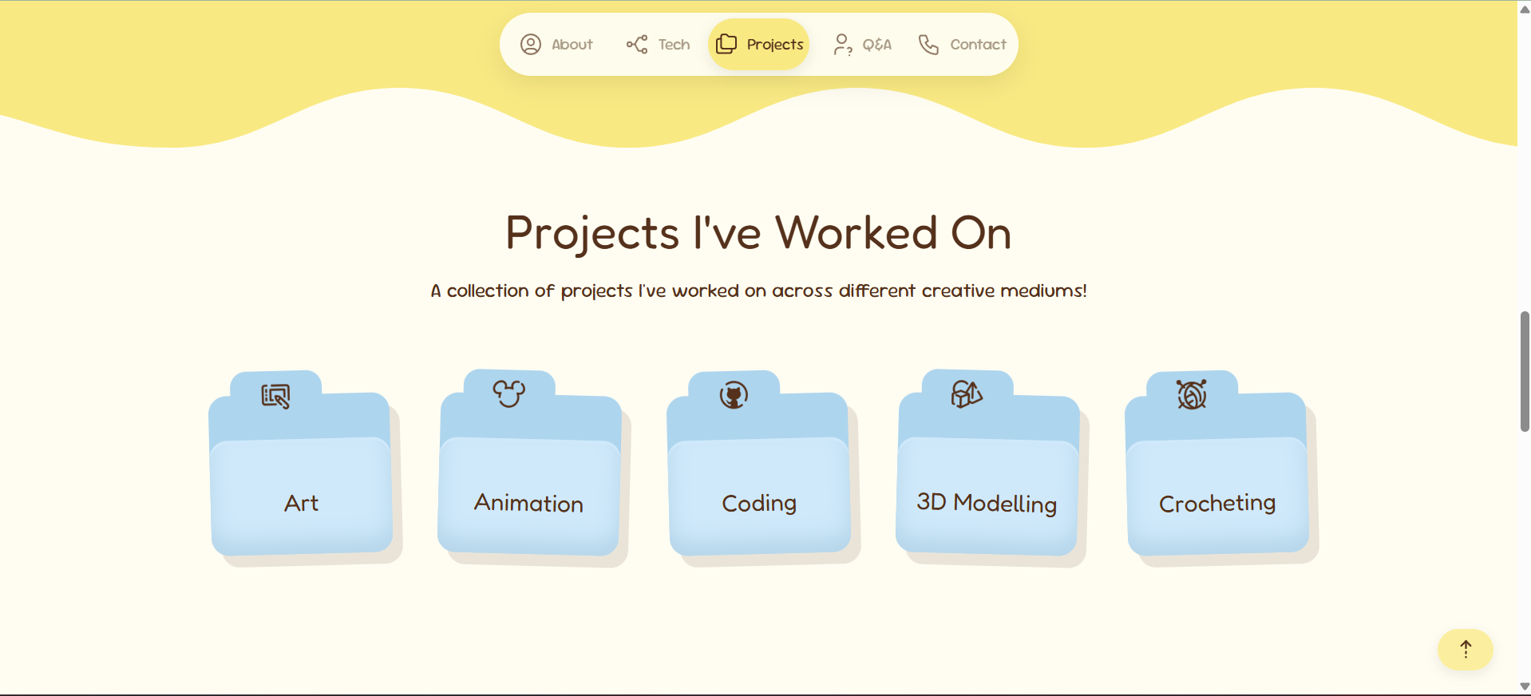

After:

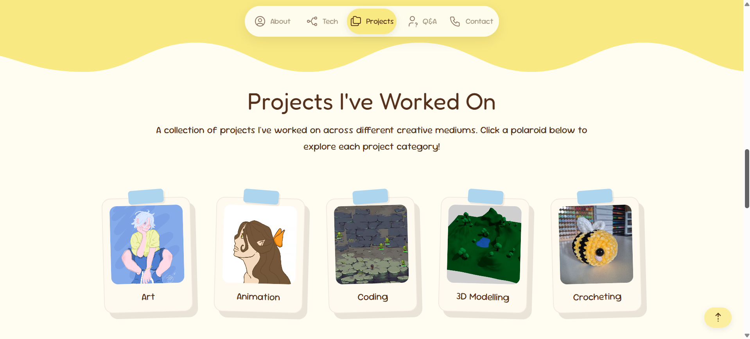

Before:



After:

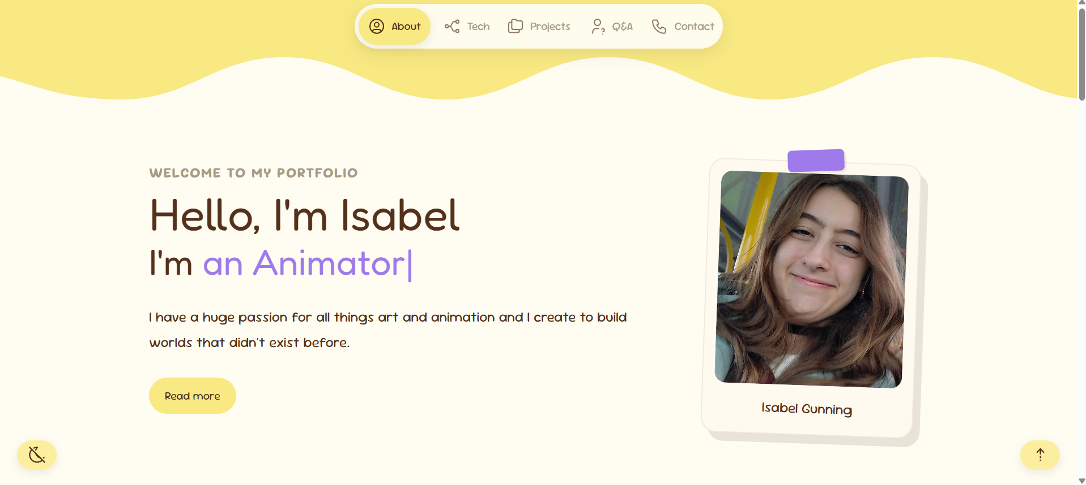

Issue 4
Participant | Family member.
Task Set | Navigating through the mobile view of the portfolio.
Issue Found | The text with the icons on the nav bar looked overcrowded on the top of the screen.
Improvements Made | Set it so that in mobile view only the icons are visible to give then more space and make it feel less cluttered.

Issue 5
Participant | Friend.
Task Set | Interact with the tech section of the website
Issue Found | As someone who struggles with red – green colour-blindness they found the pastel colour palette hard to distinguish and read.
Improvements Made | To make my portfolio more inclusive I added a dark mode with a choice of better contrasted colours to make the website visually more accessible for others.

Conclusion

Overall, I am very happy with the final design of my portfolio website. By having others test my design I was able to identify any weaknesses as I went along. Throughout the development of the website, I was able to improve the usability, accessibility and the overall design of the website making my final portfolio design feel responsive, accessible and user friendly.

